- Review & Practical

Q1. Open Cisco Packet Tracer and create a new project file named 'HomeWiFiNetwork.pkt' with three PCs and one wireless router connected appropriately?

Answer

- Home Wi-Fi Network Topology
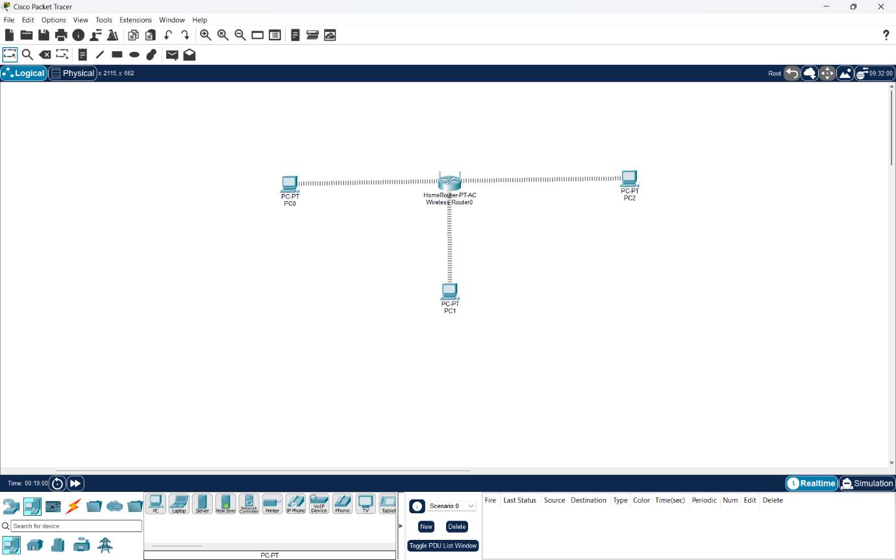
I created a new Cisco Packet Tracer project named HomeWiFiNetwork.pkt with one wireless router, and three PCs connected appropriately.

Q2. Assign static IP addresses to each PC in your Packet Tracer network so they are on the same subnet (e.g., 192.168.10.x), and configure the default gateway to the router's IP?

Answer

- Static IP Configuration
I assigned static IP addresses to all three PCs in the same 192.168.10.0/24 network.
- PC0: 192.168.10.10
- PC1: 192.168.10.20
- PC2: 192.168.10.30
- Subnet Mask: 255.255.255.0
- Default Gateway: 192.168.10.1

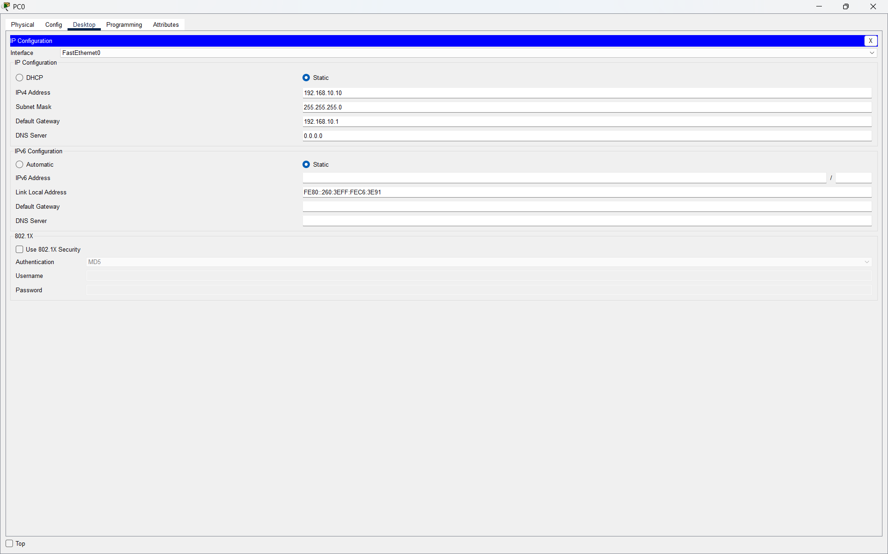
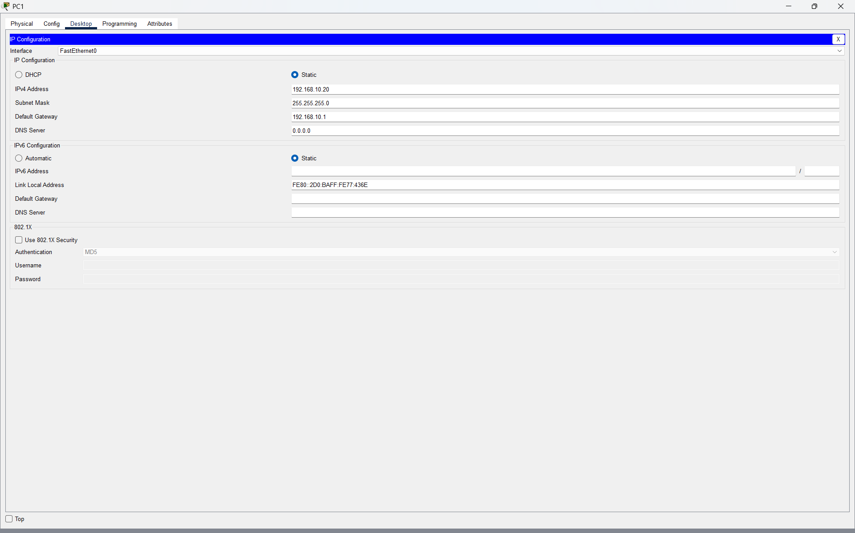
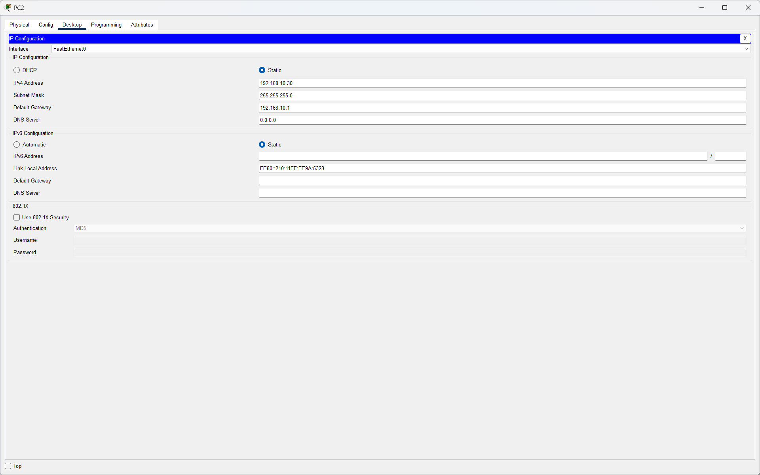
- Result:
All three PCs were successfully configured with unique static IP addresses on the same subnet.

Q3. Test connectivity by using the Packet Tracer 'ping' tool to verify that all PCs can communicate with each other and the router.<br><br><em><strong>Hint:</strong> Use the Command Prompt tool on each PC and type 'ping [other PC’s IP]'.</em>?

Answer

- Connectivity Test
I tested connectivity from PC0 to the other PCs and the router using the ping command.
- ping 192.168.10.20
- ping 192.168.10.30
- ping 192.168.10.1
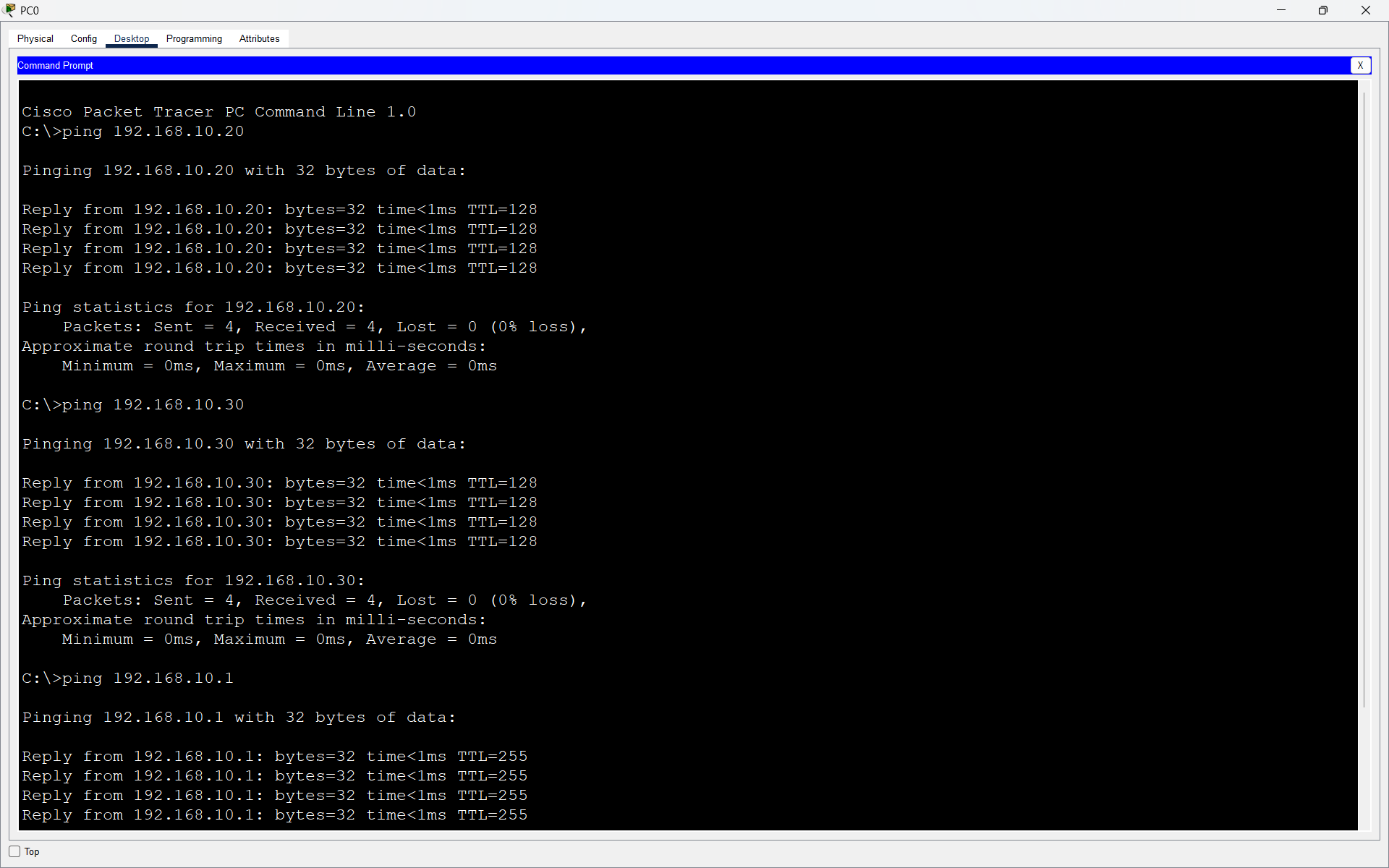

- Result:
All ping tests were successful, confirming that the three PCs and the router could communicate correctly on the same network.

Q4. Document each step you took to build and configure your Packet Tracer network, including screenshots of your topology and the IP configuration windows for each PC, in a Word or PDF file?

Answer

- Documentation of Packet Tracer Network Setup
- I created a home network in Cisco Packet Tracer using one Home router PT-AC, and three PCs.
- First, I placed one HomeRouter-PT-AC and three PCs (PC0, PC1, and PC2) in the Packet Tracer workspace. I then connected all three PCs wirelessly to the HomeRouter-PT-AC.
- Next, I configured the router with the IP address 192.168.10.1 and subnet mask 255.255.255.0.
Then I assigned static IP addresses to the PCs:
- PC0: 192.168.10.10
- PC1: 192.168.10.20
- PC2: 192.168.10.30
- Default Gateway for all PCs: 192.168.10.1
- Subnet Mask: 255.255.255.0
After configuration, I tested connectivity using the ping command. All devices were able to communicate successfully.





- Result:
The Packet Tracer home network was created and configured successfully. All three PCs were assigned static IP addresses in the same subnet and used the router IP 192.168.10.1 as the default gateway. The successful ping tests confirmed that the PCs and router could communicate properly.

